Submitting a Smoke Management Plan (SMP) in Humboldt, Del-Norte, & Trinity Counties
The burning of vegetation in our area is regulated year-round by the North Coast Unified Air Quality Management District (NCUAQMD). In order to conduct broadcast burning, burn piles larger than 10’x10’, or burn more than one pile at a time, you will need to have an approved SMP in addition to a Non-Standard Burn Permit, and any permits that may be required by Cal Fire. The SMP application may be downloaded from the NCUAQMD website at this link.

General Notes:
- If you are applying for a Fee Waiver, then you might as well aim high with your acreage and pile estimates.
- The SMP is good for two years, so include everything you might want to burn in that time.
- If you’re applying for the waiver, you’ll have to fill out a burn permit application instead of using the online portal.

Start by filling in the contact information. So far, so good right?
- If you already have a completed Non-Standard Permit, input the six-digit code from the top left corner. If you’re submitting your SMP and burn permit together, then leave this blank.
- Input the legal description of your property, and the physical address at the site, if there is one. If you’re not sure what the legal description is, check your deed or go to the Humboldt County GIS page and either input your Assessors’ Parcel Number (APN) or zoom in until you find your property, click on it, and scroll down through the information to the Legal Description.
- Check all that apply.
- If your prep is complete, record the date, otherwise input “Ongoing” if you’re still working on it, or “N/A” if there was no prep work performed.
- Check all that apply, and estimate pile size and number. Don’t worry about getting this exact; you’ll have a chance to record more accurate numbers after your burn. Check broadcast for any area that you want to use prescribed burning, and including any tractor piles and hand piles will allow you to burn larger than 10’x10’ and more than one at a time.
- This is where it starts to get tricky. Use their chart to estimate the tonnage of any pile burning. If you need help estimating tonnage for broadcast burning, either refer to a professional forester or contact the Humboldt County Prescribed Burn Association for assistance.
- Input total acreage of burn
- Be realistic. If there are heavy fuels such as stumps and logs in your project, you can expect them to take a minimum of several days to be consumed unless you plan on mopping up the whole unit.
- Input the range in elevation of your burn project (such as 1200-1400ft), and the general direction that the slope faces. A large project may encompass multiple aspects, i.e. “North, East, & South.”
- Follow the link in #2 above, zoom in on your site until the scale is appropriate for a 5 or 20 mile radius, and make a list of the sensitive receptors within that range. Make sure you include all towns, schools, hospitals, airports, and major thoroughfares. Record the cardinal direction of each receptor from your project, so that you can use it later, in the SMP Spreadsheet. If your burn is more than 100 acres, you’ll need to produce a map. You can use the Print feature to download a map, where you’ll indicate a 20 mile radius, and the sensitive receptors within it. You’ll also indicate direction of smoke, which can be essentially every direction that doesn’t impact a receptor.
- Explain what measures you will take to suppress the burn if it negatively affects a sensitive receptor, such as; “resources will be available to initiate suppression efforts and mitigate any unforeseen smoke impacts.”
- Check the boxes appropriately; There are generally no monitoring requirements unless the burn is more than 250 acres, or it’s a multi-day burn with heavy fuels and over 100 acres.
- Input “Refer to spreadsheet”
- If you have chipped some areas, or used “lop & scatter” in areas that you don’t plan to burn, indicate that here. Also, if fuel prep work will be allowed to dry for at least two weeks before ignition, indicate that as well.
- Adequate public notification is critical to a successful burn. Do a good job of it, and explain your plan here to get credit for your good work! At a minimum you will need to call each school that will be in session during your burn, that falls within the area outlined in question 10 above. You will also want to inform the local news outlets.

Spreadsheet: If your project has multiple units, fill out a separate line for each one, and give them a unique identifier in the first column. Most projects larger than a few acres benefit from being divided into units, and it is advisable to keep individual units smaller than 100 acres. If you are planning both broadcast and pile burning in a particular unit, fill out a separate line for each treatment. The second column will usually be the same for every row, unless you are using geographic coordinates, in which case you can input the latitude and longitude for the center of each unit. In the third column, indicate the type of burning. The fourth column is for acreage, either the size of the unit for broadcast burning, or for pile burning input the approximate area that the material was removed from. Skip the Wind Prescription column for now, and put N/A into the Monitoring Info column, unless you have received specific instruction on monitoring requirements. In the Sensitive Receptors column, input the name, direction, and distance of the receptors you identified in question 10 above. Return to the Wind Prescription column, and input the allowable wind directions, that won’t blow towards the receptors. Of course, keep in mind that wind directions are called out as the direction they are coming from. Take a look at the example below, and note that South and West are missing from the Wind Prescription, as burning with winds from those directions could potentially impact one of those towns. If there is a compelling reason why your burn will not impact the listed receptors with a given wind, such as topographical barriers or a significant difference in elevation, you should still exclude them from your Wind Prescription, but on the day of your burn you can share your reasoning with the NCUAQMD staff and you will likely be authorized to burn.

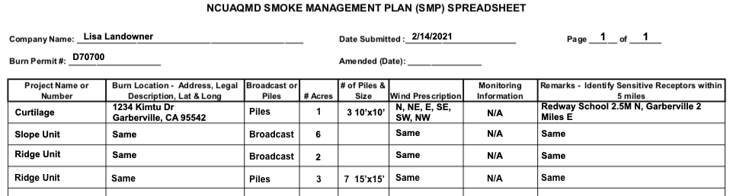

Annual Estimate of Emissions will be completed after your burn.

